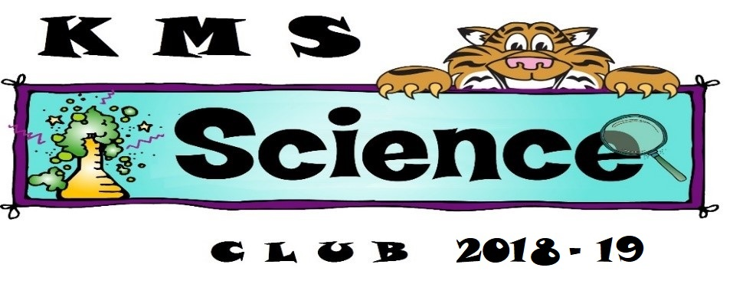
Dear Students and Parents,
It is my pleasure to extend this invitation to join the KMS Science Club for the 2018-2019 school year. This will be an after school program held once a month on a Tuesday from 2:40 – 5:00 in my Science Lab classroom. The first club meeting will be September 24, 2017 and the last will be in May. Transportation will NOT be provided. You must arrange pickup for your child AT 5:00. There is a cost of $25 per child to participate in the Science Club. This fee is used for supplies for meetings, activities, and a T’shirt for your child to keep.
I love working with our KMS kids, I love science, and I am excited to offer this opportunity to our 5th grade students. Our first meeting will be to determine officers and get to know each other and the other meetings will have an exploratory theme where we will learn about and investigate different areas of the Sciences. We may have guest speakers from various science fields or work on STEM projects. Students will also be encouraged to dig deeper into specific areas of science that they find interesting. There may also be the possibility of a Saturday field trip for students whose parents are willing to drive to the destinations involved, such as Falling Waters, The Caverns, Farley Nuclear Plant, Jim Woodruff Dam Hydroelectric Plant, etc.
To be a member of the Science Club your student must have exemplary behavior and a real desire to explore more of the sciences. If there are behavior issues, after a written warning, students may be denied membership and fee will not be returned. Attendance is very important and if they are absent it can affect the work of the group. If your child must miss a meeting due to illness, etc. please notify me through e-mail (becky.franklin@wcsdschools.com) or a written note. The limit of absences for the year is 2 unless there are extenuating circumstances which are cleared with me. Attendance, desire to learn, and good behavior is mandatory to being a member of the club. Students MUST be on their best behavior to be a part of the Science Club. This will be for the whole school year with one meeting each month. There will be a total of 18 positions open. Any student who brings their completed form to me after the 18 slots are filled will be put on a waiting list until November 29, 2016. Club fees will be due by the first meeting, Sept. 24, 2018 in you are accepted.
Please complete the attached registration form and return it as soon as possible. Spots are limited and will be first come until filled. On Sept 24, club fees are due unless you have made alternative arrangements with me. We will continue to meet one Tuesday each month with the meeting dates sent home after the first meeting. Pick-up is PROMPTLY at 5:00pm at the front car-riders area in front of the school.
If you have any questions, please feel free to email me at becky.franklin@wcsdschools.com. or call me at 850-638-6220, ext 2139. I am excited to offer this club to our 5th grade students and look forward to having a great time investigating and exploring science with your children. Also if you would like me to contact you by email, please make sure I have your email address on the application form and please write clearly. Miss Becki Franklin Please keep this page for your records
Kate M Smith Elementary School Science Club
Application for 2018 – 19
TO BE COMPLETED BY THE APPLICANT’S PARENT/GUARDIAN
Forms need to be returned as soon as possible to hold a spot and please write clearly.

Student’s Name:___________________________ Grade:_5_ Teacher:___________________
Parent’s
Name:_______________________________________ Phone :__________________________

Alternate Phone:______________________ Parent Email:_________________@__________
Shirt size:________________ Put actual shirt size and I will order 1 size larger due to small fit.
Please list people with permission to pick student up from club meetings:_________________ (only these people will be allowed to pick your child up)
_____________________________________________________________________________
_____________________________________________________________________________
I understand that meetings will be once a month, most likely on a mid-month Tuesday, but can alter if something comes up (notification will be given in advance of changes in schedule). The first Science Club meeting will be Sept 24th. I understand that my child must always have good behavior while at club meetings. Each child will pay $25 by the first club meeting (Sept 24). This will cover any supplies used in meetings for the 2018-19 school year as well as a Science Club T-shirt. Club meetings are from 2:40 to 5:00pm. I understand that I MUST arrange for pick up for my child at the front of the school at 5:00pm every meeting. I hereby give permission for my child to participate in the KMS Science Club for 2018-2019. I also understand that photos will be taken of club activities and give my permission for my child to be photographed as part of documentation of the Science Club’s activities and to share with local businesses and papers.

Parent’s Signature:__________________________________________ Date:______________

TO BE COMPLETED BY THE APPLICANT’S HOMEROOM TEACHER:

______________________________________
Homeroom Teacher’s Name
Please rate this student on the following areas of performance using the number scale below:

Student:____________________________________________________
0=Unsatisfactory 1=Needs Improvement 2=Fair 3=Good 4=Excellent

- Listens Well:__________ 5) Works well with others:_________

- Follows directions:__________ 6) Works independently:__________

- Practices self-control:__________ 7) Respectful & courteous:__________

- Follows classroom/school rules:__________ TOTAL SCORE:__________
Applicants must score 20 or above to be considered for KMS Science Club membership.

Teacher Signature:________________________________ Date:_______________________

